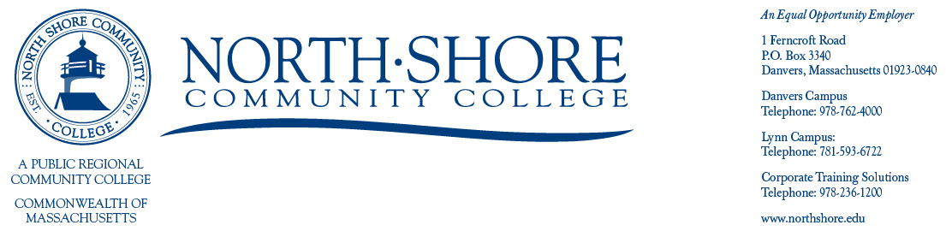

March 7th, 2022

Open Meeting Notification

North Shore Community College
Board of Trustees

Please be advised that the March Meeting of the Board of Trustees will be held on

March 22, 2022 from 4:45 – 6:30pm

Lynn Campus Community Conference Room, LS328
300 Broad Street, Lynn, MA 01901

and via Zoom

Join Zoom Meeting https://northshore-edu.zoom.us/j/99315549495

Meeting ID: 993 1554 9495

One tap mobile +13017158592,,99315549495# US (Washington DC)
+13126266799,,99315549495# US (Chicago)

Trustee meetings and notices are posted on the following website:

http://www.northshore.edu/about/administration/board.html

Sincerely,

Miranda Gualtieri
Board of Trustees Liaison
(978)762-4000 ext. 5563
Mgualtie01@northshore.edu

