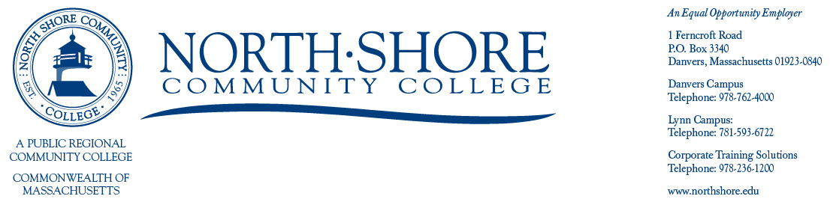

March 7th, 2022

Open Meeting Notification

North Shore Community College
Board of Trustees
Finance Committee

Please be advised that the Finance Committee will meet on

Tuesday, March 15th via Zoom

3:00pm-4:00pm

Join Zoom Meeting
https://northshore-edu.zoom.us/j/97672263081
Meeting ID: 976 7226 3081
Passcode: 200864
One tap mobile
+13017158592,,97672263081# US (Washington DC)
+13126266799,,97672263081# US (Chicago)

AGENDA

Budget Discussion

Trustee meetings and notices are posted on the following website:

http://www.northshore.edu/about/administration/board.html

Sincerely,

Miranda Gualtieri
Board of Trustees Liaison
(978)762-4000 ext. 5563
Mgualtie01@northshore.edu

